Supplemental Materials

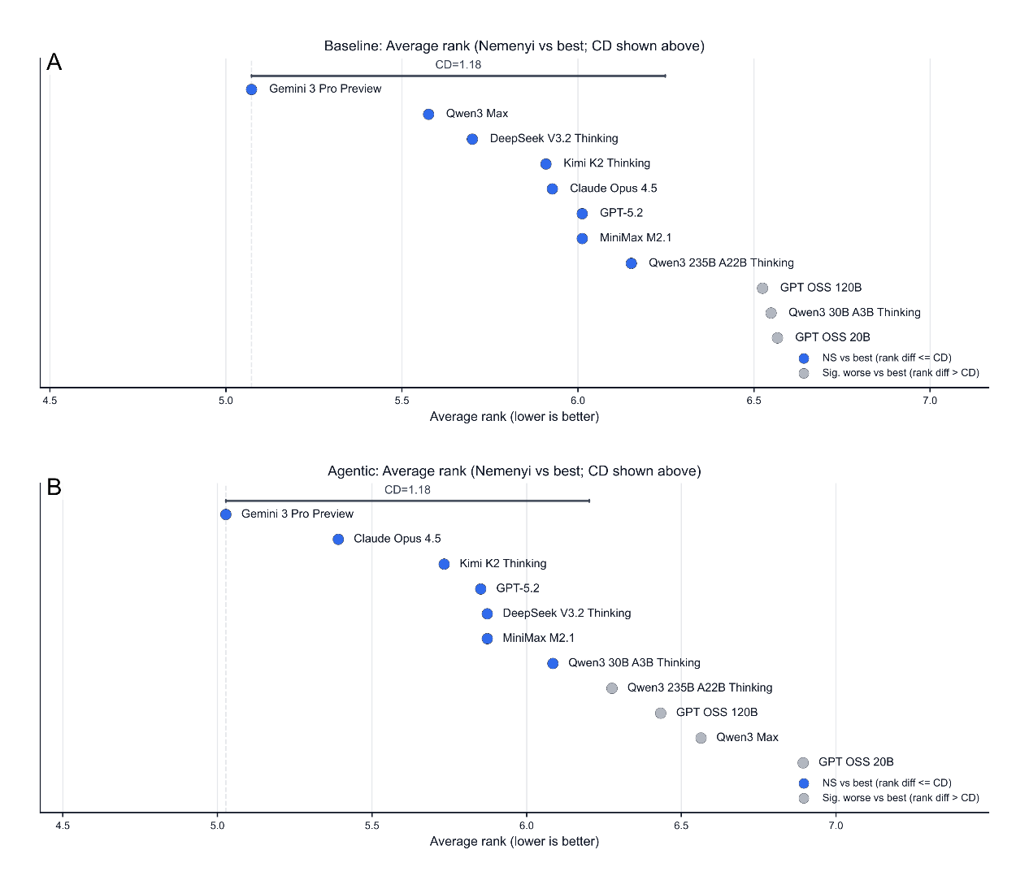
Fig.S1. Nemenyi critical-difference (CD) diagrams for baseline and agentic evaluations.
Average model ranks computed across the 165 items (lower is better), with the Nemenyi CD (α=0.05) shown as a reference bar. Models are colored by whether they are significantly worse than the best model (rank difference > CD). Panel A: baseline; Panel B: agentic.

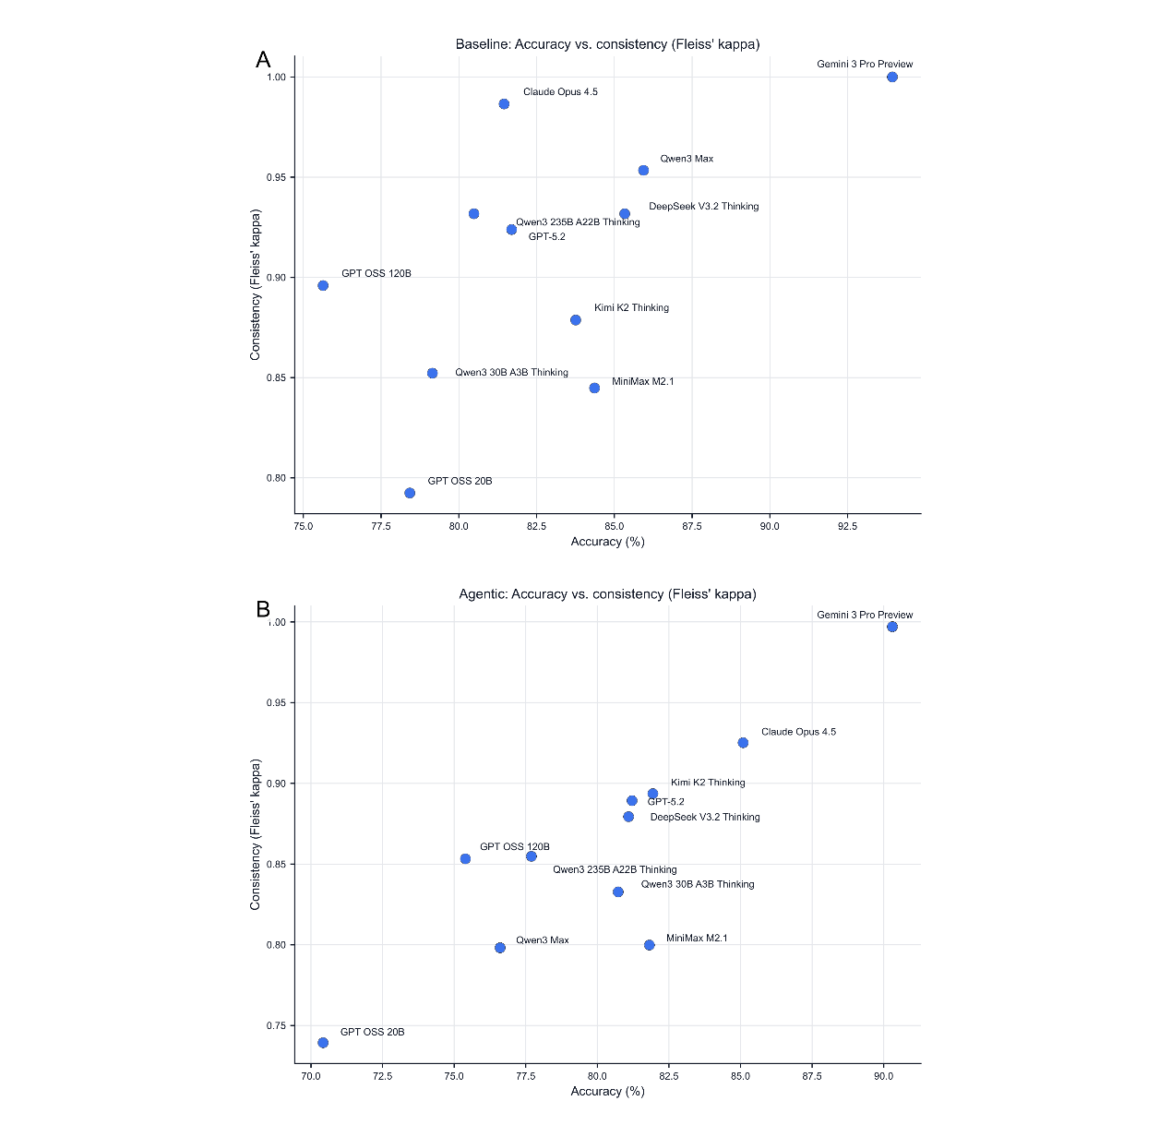
Fig. S2. Accuracy vs self-consistency across repeated trials.
Relationship between mean accuracy and Fleiss' κ for each model. Panel A: baseline; Panel B: agentic.
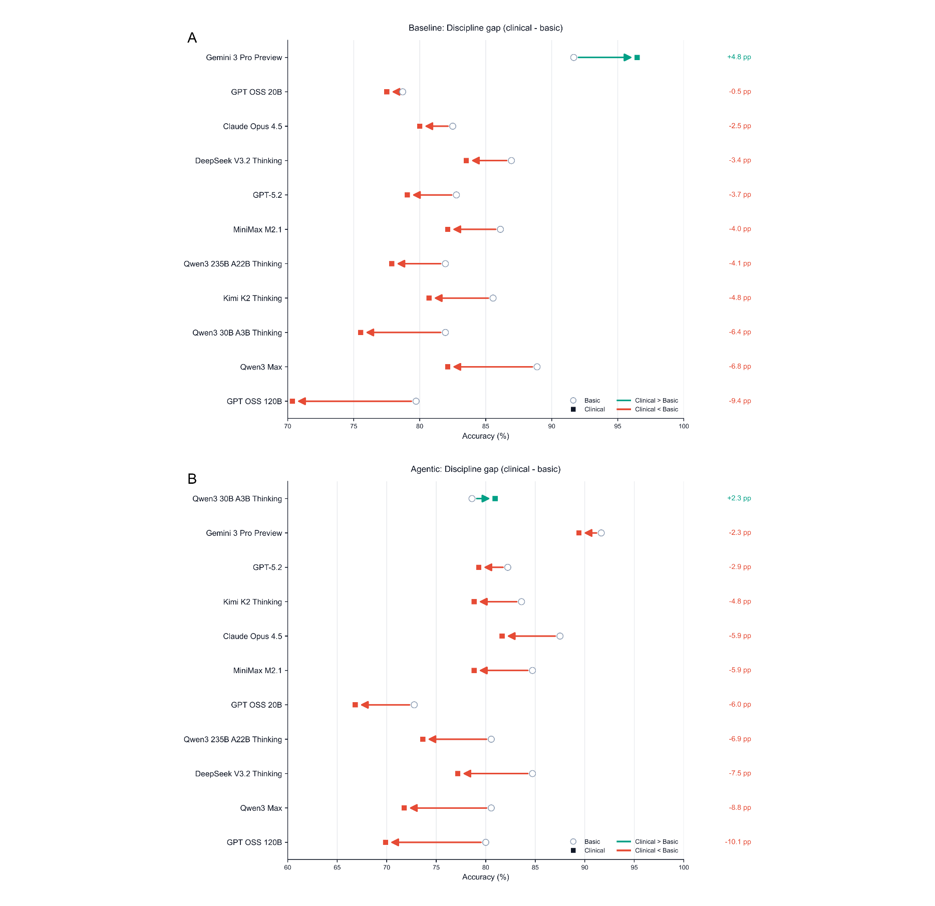
Fig. S3. Discipline gap between basic sciences and clinical disciplines.
For each model, dumbbell arrows compare accuracy on basic sciences (Physiology/Biochemistry + Pathology; circle) versus clinical disciplines (Internal Medicine + Surgery; square). The right-aligned label reports the clinical-minus-basic gap in percentage points. Panel A: baseline; Panel B: agentic.
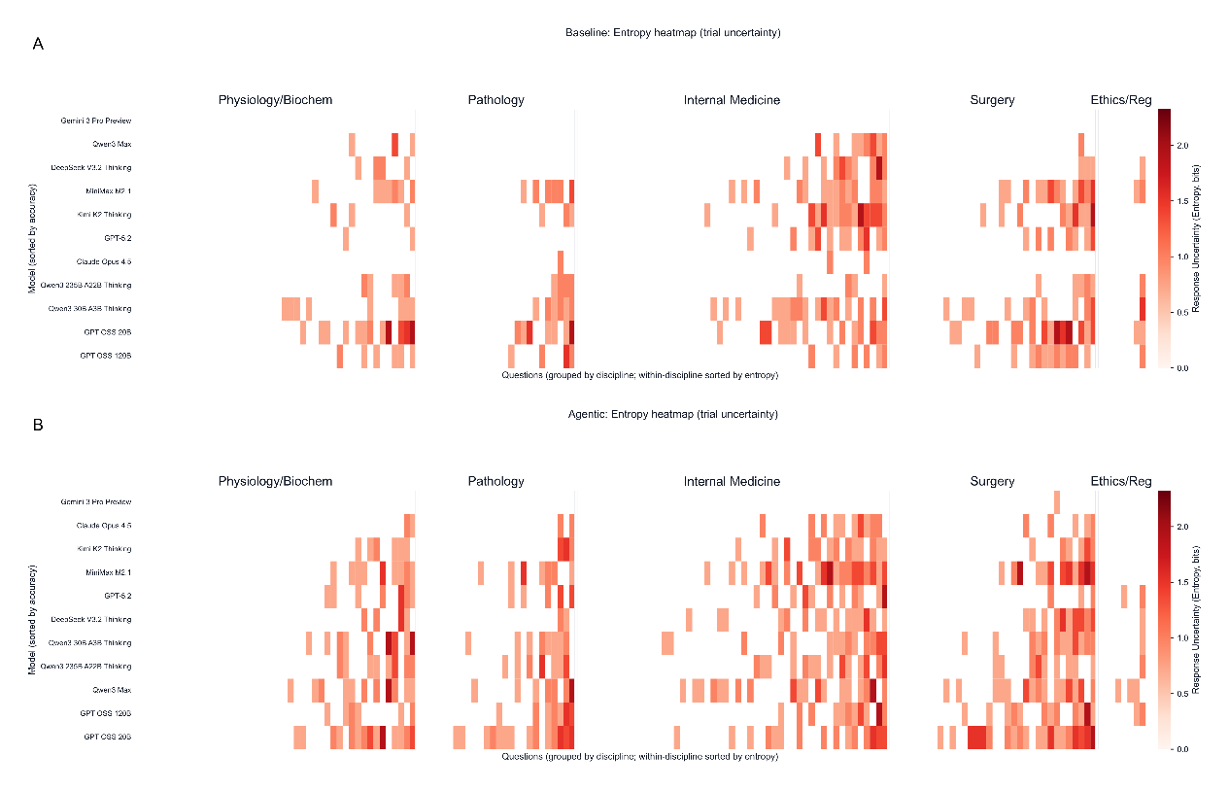Fig. S4. Entropy heatmaps of trial-to-trial output uncertainty.
Per model-item response uncertainty quantified as Shannon entropy (bits) over the distribution of selected options across 5 trials. Cells with zero entropy (identical outputs across trials) are masked in white. Items are grouped by discipline and sorted within each discipline by the across-model mean entropy; models are ordered by overall accuracy. Panel A: baseline; Panel B: agentic.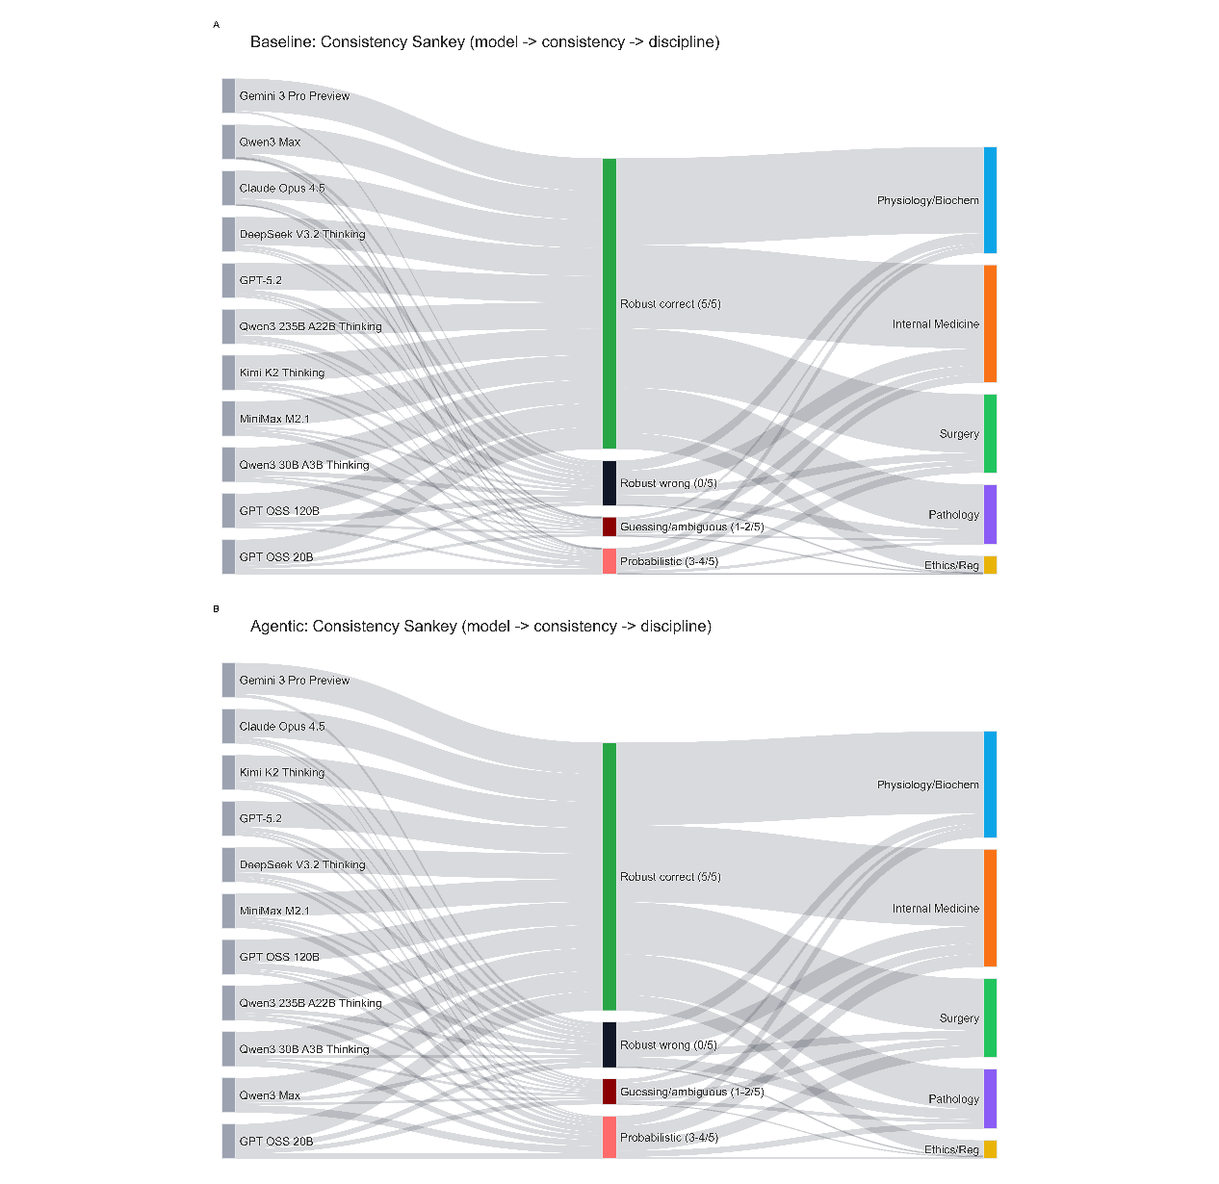
Fig. S5. Consistency Sankey.
Sankey diagrams summarizing stability categories based on the number of correct trials for each model-item pair: robust correct (5/5), probabilistic (3-4/5), guessing/ambiguous (1-2/5), and robust wrong (0/5). Left flows show the per-model distribution across the 165 items; right flows summarize the overall discipline composition of each stability category aggregated across all models. Panel A: baseline; Panel B: agentic.
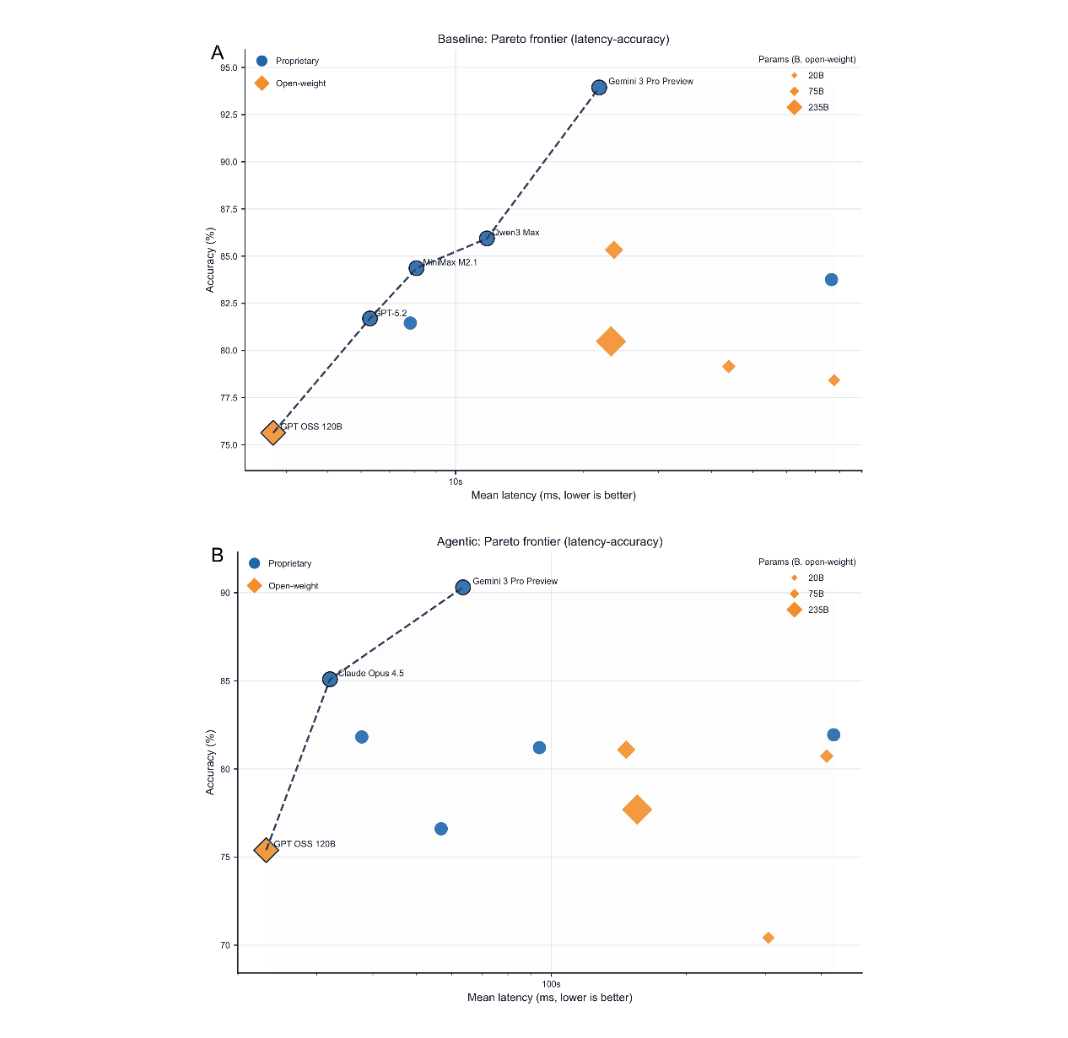
Fig. S6. Latency-accuracy Pareto frontiers under baseline and agentic protocols.
Scatter plots of mean latency (log scale; lower is better) versus mean accuracy for each model. Marker shape encodes model availability (proprietary vs open-weight); bubble size reflects parameter count when available (open-weight models). The dashed curve indicates the Pareto frontier (non-dominated models). Panel A: baseline; Panel B: agentic.
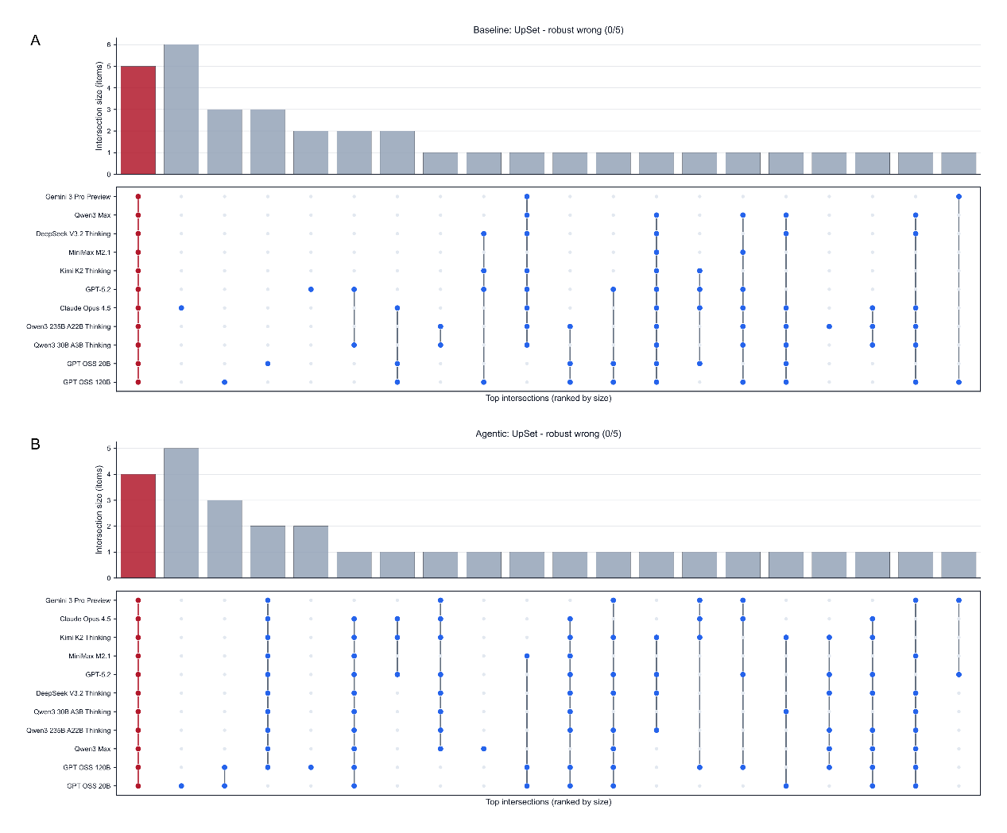
Fig. S7. UpSet plots of "robust wrong" (0/5 correct) intersections across models.
UpSet plots summarize intersections of items that were robust wrong (0/5 correct across trials) for different subsets of models. The bar chart reports the number of items in each intersection (top intersections ranked by size), and the dot matrix indicates which models are included in each subset (models ordered by overall accuracy). The all-models intersection, when present, is highlighted. Panel A: baseline; Panel B: agentic.

